You should spend about 20 minutes on this task.

The line graph shows thefts per thousand vehicles in four countries between 1990 and 1999.

Summarize the information by selecting and reporting the main features and make comparisons where relevant. Write at least 150 words.

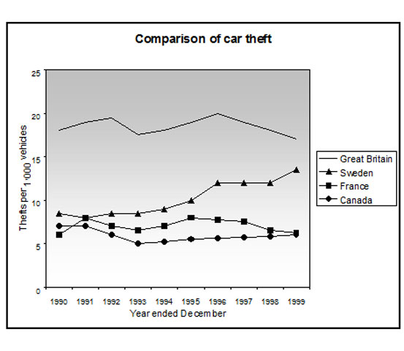

The line graph illustrates the total number of cars reported stolen per 1,000 vehicles in four different countries between 1990 and 1999.

In general, it can be observed that car thefts were far higher in Great Britain than in the other three countries, however, this trend was significantly increased in Sweden.

To begin, Great Britain experienced 17 car thefts per 1,000 vehicles in 1990, which was significantly higher than in any other country. The number of thefts then fluctuated over the next nine years, peaking at 20 thefts per 1,000 vehicles in 1996 before decreasing to roughly 17 thefts per 1,000 vehicles by the end of the period.

Throughout the entire period, France and Canada exhibited a similar pattern, with the quantity of car thefts remaining between 5 and 7 per 1,000 vehicles. In contrast, Sweden was the only country to experience an increase in car thefts and the number started at about 6 thefts per 1,000 vehicles in 1990, rose dramatically to peak at 15 thefts per 1,000 vehicles in 1999.